A STUDY OF LIFE SKILL MANAGEMENT AND EMOTIONAL INTELIGENCE OF PUPIL TEACHERS

*Dr. Pramod Kumar Rajput¹

*Jugmaheer Gautam²

Abstract

This exploration paper has a place with the investigation of fundamental abilities' schooling and its impact on their capacity to understand individuals on a profound level. A student educator is a youngster who spends some portion of their time undertaking showing obligations under the oversight of the head-instructor. The capacity to understand individuals on a deeper level is the capacity to figure out some kind of harmony among feeling and reason. This is an exploratory examination with pre test and post test plan with intercession. Results portray fundamental abilities training supportive in expanding the capacity to understand anyone at their core.
Key words: life skills education, emotional intelligence, pupil teachers.

Introduction
Human conduct alludes to the manner in which people connect with one another. These ways of behaving are changed continually founded on and affected by different elements like hereditary qualities, mentalities, values, culture, customs, convictions, environment and so forth. Fundamentally there are two elements; heredity and climate. Frequently the progressions happened in human way of behaving are called highs and lows. These high points and low points impact life of an individual. To handle this multitude of changes and to change with them, an individual ought to lead life skilfully. Today, the current schooling system needs to audit speculations, practices and arrangements like never before. Presently it is important for educators to make another vision of schooling and preparing corresponding to their own insight. Schooling has changed totally and the assignment of the instructor is not generally restricted to the exchange of information rather the person is answerable for driving and directing the understudies. Thus, the educator, as the director of the homeroom, ought to make arrangements for the psychological, profound, moral, social, and expertise advancement of the understudies. To live tranquil life and to be composed, an individual should be adjusted in his feelings. He ought to be genuinely shrewd and this ability to understand anyone on a profound level can be improved and developed through fundamental abilities schooling. This view is upheld by a few investigations.
In a concentrate by Nelis et al. (2009), concentrate on members were separated into two gatherings. One gathering got a capacity to understand people on a deeper level preparation of four gathering meetings of 2-1/2 hours each. The other gathering got no preparation. After the treatment was finished, the preparation bunch showed a huge expansion in feeling recognizable proof and feelings the board ascompared to the benchmark group. A half year after the fact, the preparation bunch actually had a similar enhancement for feeling distinguishing proof and feeling the executives. The benchmark group showed no change. Subsequently, it demonstrates that fundamental ability preparing has a positive effect in improvement of the capacity to understand people at their core.
In another review, subjects with schizophrenia were contrasted with a benchmark group on a proportion of the capacity to understand people on a profound level utilizing Mayer-Salovey-Caruso The capacity to appreciate people on a profound level Test (MSCEIT). Subjects with schizophrenia performed fundamentally more terrible than those of control bunch on the all out MSCEIT score. They likewise performed fundamentally more regrettable than those of .control bunch on three out of four MSCEIT subtests: Recognizing, Understanding, and Dealing with Feelings. Likewise, there was a critical expansion in negative and scattered side effects in schizophrenic subjects with lower MSCEIT scores. Lower MSCEIT scores were additionally altogether corresponded with additional troubles in local area working Kee et al(2009). This study uncovers that individuals enduring with schizophrenia are bad fair and square of the capacity to understand anyone on a profound level.
In comparable sort of study directed by Tune et al. (2010), the effect of General Mental Capacity (GMA) and The ability to understand anyone on a profound level (EI) on undergrads' scholar and social execution was contemplated. While GMA and EI both impacted scholarly execution, GMA was viewed as a more grounded indicator of scholastic execution than EI. Nonetheless, EI, as opposed to GMA, was connected with the nature of social cooperations with peers. This study portrays positive connection between the capacity to appreciate people on a profound level and social execution however broad mental capacity significantly affected scholarly execution when contrasted with the ability to understand individuals at their core. It implies GMA was viewed as a more grounded indicator of scholarly execution than EI. Be that as it may, EI, rather than GMA, was connected with the nature of social cooperations with peers.
Roodbari et al (2011) directed a concentrate on the impact of fundamental abilities training on friendly formative, profound and social similarity among 1st grade female secondary school and found that the viability of fundamental abilities instruction programs in upgrade of understudies' personal change, social change and social turn of events.
One more Review was directed by Tarun (2011) on effect of fundamental abilities intercession schooling on expanding the capacity to understand people on a deeper level of undergrads. Consequence of the review demonstrated that fundamental abilities schooling prompted a huge increment of the capacity to understand people on a deeper level in concentrate on bunch as opposed to control bunch subjects.

A, research study was done by O'Boyle, et al. (2011) on the connection between the capacity to understand individuals on a profound level and occupation execution: A meta-analysis.This meta-examination expands upon a past meta-investigation by (1) including 65 percent more investigations that have over two times the example size to gauge the connections between the capacity to understand people on a deeper level (EI) and work execution; (2) involving more current meta-scientific examinations for evaluations of connections among character factors and for mental capacity and occupation execution;
(3) utilizing the three-stream approach for characterizing EI research; (4) performing tests for contrasts among floods of EI research and their associations with character and mental knowledge; (5) utilizing most recent factual strategies like predominance investigation; and (6) testing for distribution inclination. EI review were grouped into three streams: (1) capacity based models that utilization objective test things; (2) self-report or companion report estimates in light of the four-branch model of EI; and (3) "blended models" s. of close to home abilities. The three streams have rectified relationships going from 0.24 to 0.30 with work execution. The three streams associated contrastingly with mental capacity and with neuroticism, extroversion, transparency, appropriateness, and principles. Streams 2 and 3 had the biggest steady legitimacy past mental capacity and the Five Variable Model (FFM). Strength examination showed that each of the three floods of EI displayed significant relative significance within the sight of FFM and insight while anticipating position execution. Distribution inclination had irrelevant impact on noticed impact sizes. The outcomes upheld the general legitimacy of EI.

Operational definitions:
Functional meanings of the factors of this study has been made sense of beneath

Life Skills Education
"Fundamental abilities" are characterized as psychosocial capacities for versatile and positive way of behaving that empower people to manage the requests and difficulties of day to day existence. It is the method involved with working with learning or the obtaining of information on abilities values, convictions and propensities.

Emotional Intelligence
The capacity to understand people on a profound level is the capacity to figure out some kind of harmony among feeling and reason, monitoring one's own feelings, show sympathy and empathy for other people and have a high confidence by understanding and dealing with the feelings of self and others.

Objective
To concentrate on the impact of fundamental abilities training on capacity to appreciate anyone on a profound level of understudy educators.

Hypotheses
There is no massive impact of fundamental abilities instruction on capacity to appreciate people on a deeper level of understudy instructors.

Design of the Study
This is a trial research with pre test and post test plan. Subjects have been partitioned into trial bunch (A) and control bunch (B) by comparing them based on pre-test scores of EIT. The review is engaged with three stages which included organization of pre-test, mediation program and organization of post test. The accompanying method has been embraced for leading the review
Stage 1 Organization of pre test
Stage 2 Intercession program
Stage 3 Organization of post test

Population and Sample
First and foremost, out of twelve educators trade schools of Locale Muzaffarnagar (UP), four instructors trade schools have been chosen haphazardly. Out of these four chose universities, 400 student instructors have been chosen haphazardly. These chose student educators from these schools have been allocated into two gathering I. e. exploratory and control gathering of 200 each.

Data and Sources of Data
The specialist chose four educator trade schools haphazardly from locale Muzaffarnagar. Uttar Pradesh. She looked for consent from administrators of these schools. In the wake of taking consent, specialist granted a direction with respect to fundamental abilities schooling to understudy educators then she regulated a trial of EI to 400 subjects to liken them into two gatherings for example trial bunch (A) and control bunch (B). The review included three stages which incorporates organization of pre-test, mediation program and organization of post test (Table-1). The accompanying strategy has been embraced for directing the review; Stage 1 Adminstration of pre-test, Stage 2 Intercession program and Stage 3 Organization of post-test.

Statistical Tools and psychological tests
Following measurable instruments and mental tests have been utilized to lead the review

Descriptive Statistics
Following distinct measurable apparatuses have been utilized for present review:
Mean, middle, mode, skewness, standard mistake of skewness, kurtosis, standard blunder of kurtosis, bar outline have been utilized to portray information concerning pre test and post trial of the review.

Inferential Statistics
t test has been utilized to construe information concerning pre test and post trial of the review.

Psychological Tests
Following mental tests have been utilized for the current review:
Educators' Capacity to appreciate individuals on a profound level Stock by Mangal (2005).
Module of Fundamental abilities Schooling has been created by the specialist under the direction of manager.

IV. Results and discussion:
Information examination of this study has been introduced in two segments Area
a-spellbinding outcomes Area
b-inferential outcomes

SECTION-A: DESCRIPTIVE RESULT
Table-1: Distribution of emotional intelligence scores before and after intervention

 | Emotional Intelligence before Intervention | Emotional Intelligence after Intervention
Mean | 688.90 | 774.35
Median | 675.00 | 789.00
Mode | 615ª | 890
Skewness | -.299 | -.806
Std. Error of Skewness | .122 | .122
Kurtosis | 1.349 | 1.830
Std. Error of Kurtosis | .243 | .243
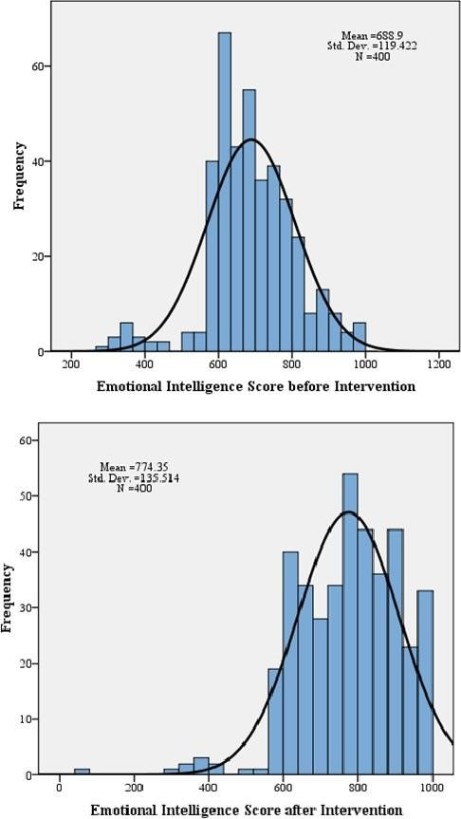

Table-2: Test for Equality of Means of Experimental and Control Group regarding Emotional Intelligence

Condition | N | Mean | Std. Deviation | Std. Error Mean
Experimental | 200 | 690.86 | 120.470 | 8.518
Control | 200 | 686.94 | 118.634 | 8.389

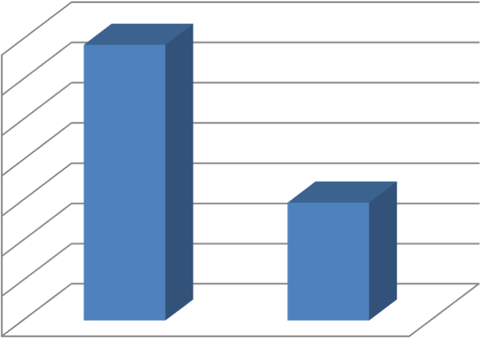 Figure-1: Bar Graph for Means of Experimental and Control Group regarding Emotional Intelligence
Emotional Intelligence
690.86
691
690
689
688
687
686
685
684
686.94
EmotionalIntelligence
Experimental Control

Table-3: t-Value for Equality of Means of Experimental and Control Group regarding Emotional Intelligence

Mean Difference | Df | Std. Error Difference | t-Value | Sig. (2-tailed)
3.920 | 398 | 11.956 | .328 | NS
NS= Mean Difference is NOT Significant

SECTION-B: INFERENTIAL RESULTS

Table-1: Pre and Post Interventional Mean Scores on Emotional Intelligence of Pupil Teachers
 | Emotional Intelligence | Mean | N | Std. Deviation | Std. Error  Mean
Experimental Group | Before Intervention | 690.86 | 200 | 120.470 | 8.518
 | After Intervention | 862.50 | 200 | 77.235 | 5.461
Control Group | Before Intervention | 686.94 | 200 | 118.634 | 8.389
 | After Intervention | 686.20 | 200 | 123.435 | 8.728

Table-2: Paired t-Value for Pre-Post Mean comparison regarding Emotional Intelligence
 | Mean Difference | Std. Error Mean | df | t-Value | Sig. (2-  tailed)
Experimental  Group | 171.635 | 9.58 | 199 | 17.910 | .000
Control Group | .745 | 2.68 | 199 | .278 | NS

Figure-2: Bar Graph for Pre-Post Mean comparison regarding Emotional Intelligence

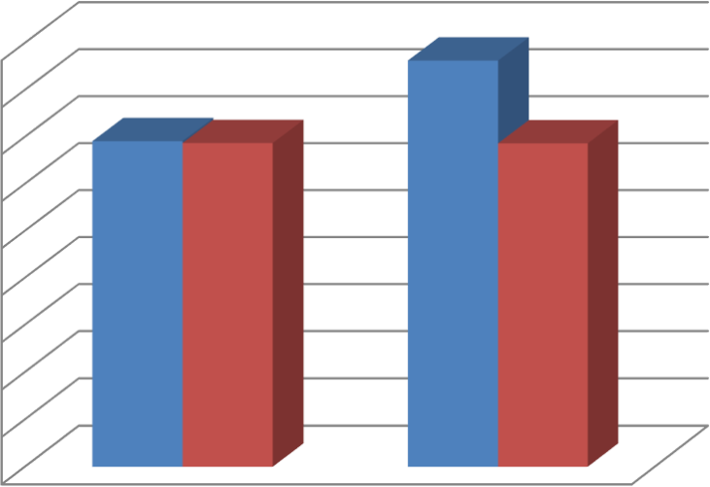
900
800
700
600
500
400
300
200
100
0
862.5
690.86686.94
686.2
Experimental
Control
BeforeIntervention
AfterIntervention

Figure-3: Bar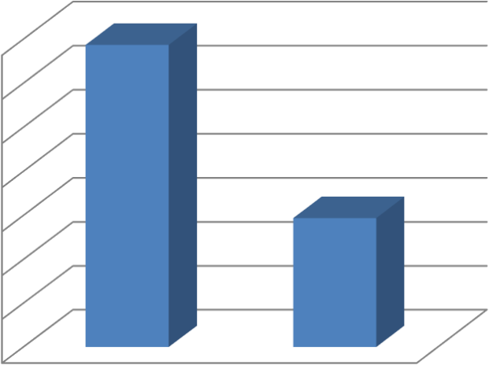
EmotionalIntelligence
690.87
691
690
689
688
687
686
685
684
686.94
EmotionalIntelligence
Experimental Control
Graph for Between-group Comparison regarding Pre- Emotional Intelligence Means

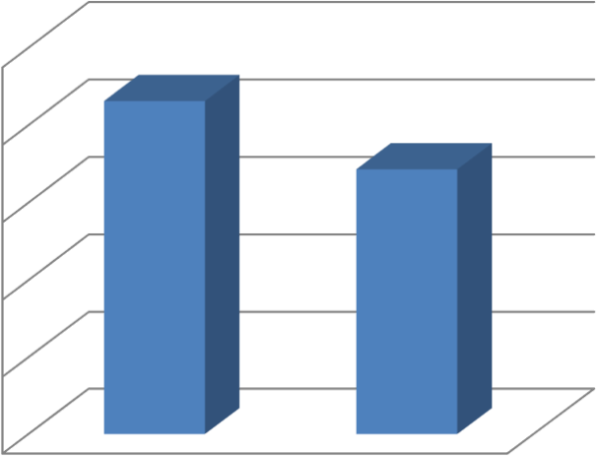
Emotional Intelligence
1000
862.5
800
686.2
600
EmotionalIntelligence
400

200
0
Experimental
Control

Speculations of this exploration paper; there is no massive impact of fundamental abilities schooling on capacity to understand anyone on a profound level of understudy educators however consequence of the concentrate as portrayed in the previously mentioned tables and figures shows that the theories of this review is dismissed on the grounds that fundamental abilities training significantly affects the ability to understand people on a deeper level of student educators. Their degree of the ability to understand individuals on a deeper level has been expanded in the wake of getting mediation. There is a huge distinction between the consequences of pre test and post test.

References:
- Abouseire, R. (1994). Sources and levels of Stress in Relation to Locus of Control and Self Esteem in University Students. Educational Psychology, 14(3): 323-330. doi:10.1080/0144341940140306
- Abu-Ghazaleh, SB., Rajab, LD.& Sonbol, HN.(2012) Psychological Stress among Dental Students at the University of Jordan. Journal Dent Educ,18(4):122-131
- Admiraal, W.F., Korthagen, F.A.J. & Wubbels, T. (2000).Effects of student teachers' coping behavior. British Journal of Educational Psychology, 70(15): 33-52. doi: 10.1348/000709900157958
- Agarwal, M., Dalai, AK., Agarwal, DK.& Agarwal, RK.(1995).Positive Life Orientation and Recovery from Myocardial Infarction, SocSci Med, 40(1):25-39.
- Aldwin, C., Greenberger, E. Cultural Differences in the Predictors of Depression. American Journal of Commun.ity Psychology, 15(6):789-813.
- Auerbach, SM. & Gramling, SE.(1998) Stress Management: Psychological Foundations. Upper Saddle River, N.J.:Prentice Hall.
- Behere, SP., Yadav, R. & Behere PB.(2016) A Comparative Study of Stress among Students of Medicine, Engineering, and Nursing. Indian J Psychol Med,33(4):45-58.
- Bernstein, DA., Penner, LA., Stewart, AC., & Roy, EJ.(2008). Psychology (8th edition).Boston, New York: Houghton Mifflin Company.
- Bibi, S., Sacilain, S. & Mussawar, B. (2016) A Study on Relationship between Emotional Intelligence and Self Esteem among Pakistani University Students. J Psychol Psychother doi:10.4172/2161- 0487.1000279
- Brahmaiah, T. (2009).Stress of Student Teachers. New Delhi: Discovery Publication House.
- Christiaans, DJ.(2006).Empowering Teachers to Implement the Life Orientation Learning Area in the Senior Phase of the General Education and Training Band.(M Ed dissertation). Stellenbosch: University of Stellenbosch.

